**Support to strengthening Statistics, Monitoring and Evaluation capacities in Comoros in the context of post-2015 Agenda**

**FINAL REPORT**

**JUNE 2017**

This project’s goal is to improve the monitoring and evaluation system of SCA2D, as part of Sustainable Development Goals through two main outputs:

1- The monitoring and evaluation system for public programs and projects in place:

2- The socio-economic database of the Comoros "Comoros-Info’s" is operational

***In terms of activities, the main activities to report are:***

***Output 1: Monitoring and evaluation system for public programs and projects is in place:***

* Two consultants (a national and an international) were recruited on the basis of a competitive process to support the restructuring of the National Monitoring and Evaluation System. Based on a preliminary evaluation of the current system for monitoring and evaluation, the two consultants provided a methodological support to upgrade the monitoring-evaluation.
* The new system was developed and validated by the Permanent Technical Secretariat in charge of the implementation of the national sustainable strategy document
* The basic training of the managers involved in the monitoring and evaluation system is implemented
* A new architecture for the monitoring and evaluation system including the coordination mechanisms is available
* A comprehensive training plan for the managers of the structures involved in monitoring and evaluation is available
* The coordination structure of the monitoring and evaluation system of the national strategy is equipped with the necessary computer equipment for the realization of its missions.
* The mains stakeholders involved in the national monitoring system are trained to better fulfill the data collection and analysis. This step is very important given the fact that the country will carry out a national census; the latest one was undertaken 20 years ago.

Thanks to the project, the country has an appropriate national capacity-building program for monitoring and evaluation. In particular, the program enabled the Government to mobilize international expertise from the African Development Bank to set up the new institutional monitoring and evaluation system and to initiate its operationalization through the training of the actors of the sectoral planning units, the reconstitution of the indicators Development programs, their annual targets, and sectoral development programs. The country is now in a better position to set up the database and indicators required for the monitoring of the implementation of the SDGs, in line with the recommendations of the MAPS mission of July 2017.

2- ***Output 2: The socio-economic database of the Comoros "Comoros-Info’s" operational. Concerning This output intend to***

* Two Experts are recruited to support the restructuring and operationalization of the Comores-Infos database.
* The national statistic institution, INSEED is equipped with the necessary equipment, hardware and other facilities NTIC for the management and operation of the database. It includes computers, external hard drive, network, server hard drives, inverters, Anti-virus, other materials for network and solar energy (see photo in annexes)
* A design for regular publication of “Comores- Info” (data base) is available
* The definition of the respective roles of the various stakeholders involved in the management of this database has been redefined for a better flow of information.
* The coordination mechanisms of the various actors involved in the management of the database is set up
* A training plan for the data analysts involved in the updating and management of the database is implemented
* A Proposal for the regular publication on website is provided
* INSEED is able to manage properly the new database system which is set up.

Thanks to the project, the statistical units, in particular the statistical branch of the University of the Comoros, have been equipped to carry out their mission. This will enable the country to have qualified human resources to work in the sector planning units. The country will also be able to rely on these young people for the collection and processing of data in future surveys and censuses. In the other hand, data storage infrastructures have been strengthened, including Comores-infos, the socio-economic database of Comoros. All the available data are now accessible to the National Institute of Statistics, Economic and Demographic Studies (INDEED) in Comores Infos. Steps are being taken to facilitate access to these data online.”

***Financial information***

In terms of fund management, resources were spent as follow:

|  |  |  |
| --- | --- | --- |
| **Description** | **No de compte** | **Dépenses** |
|
| Experts Internationaux | 71200 | 38 023.78 |
| Experts Nationaux | 71400 | 6827.28 |
| Voyages et missions | 71600 | 12 474.19 |
| Matériel | 72200 | 44 049.50 |
| Frais de fonctionnement | 74200 | 1 145.04 |
| Ateliers de formation | 75700 | 8 003.13 |
| Sundry | 74500 | 23.83 |
| **Sous-total** |  | **110 546.75** |
| Frais de gestion | 75100 | 8 843.75 |
| **Grand total** |  | **119 390.50** |

***Annexes-illustratives Pictures***

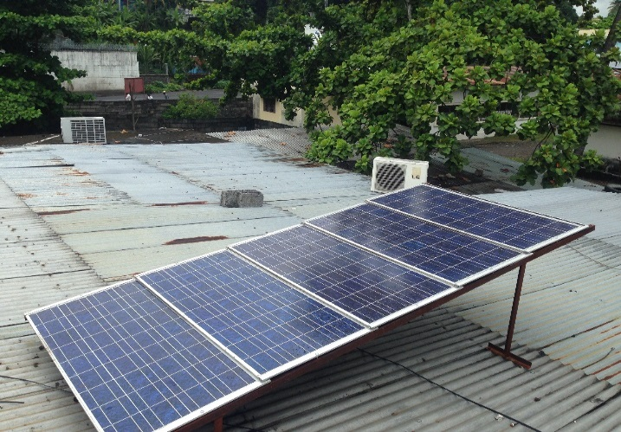

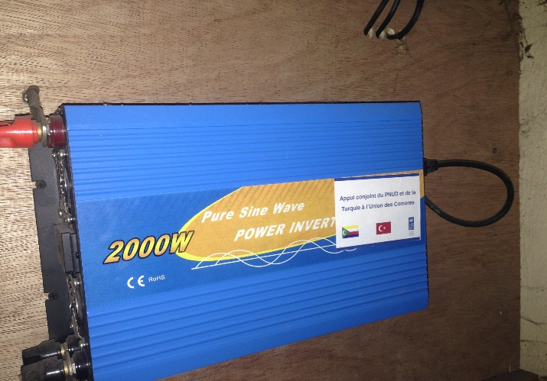

***Panneaux solaires de la salle du serveur***

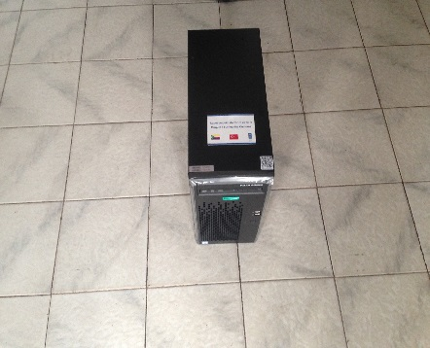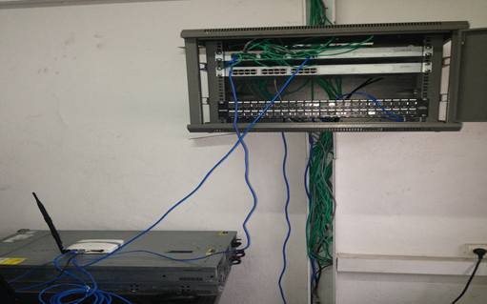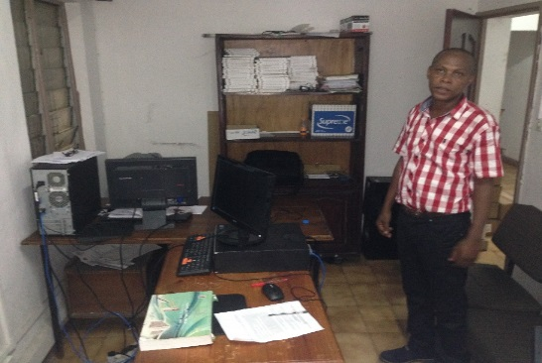

***Serveur de la base de données et matériels de connectivité***

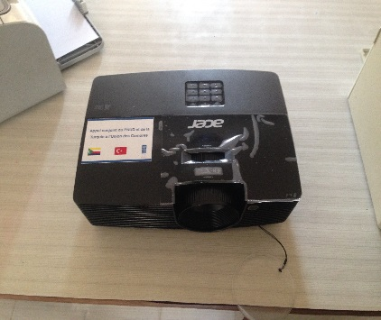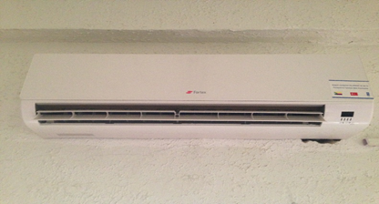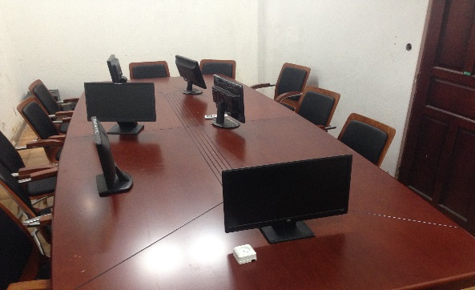

***Salle de conférence de l’INSEED***

******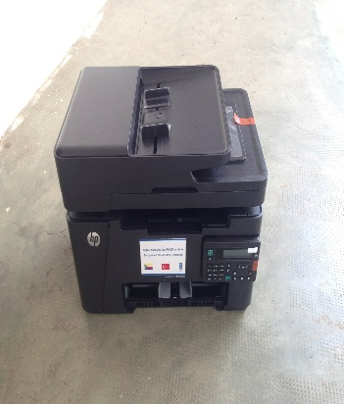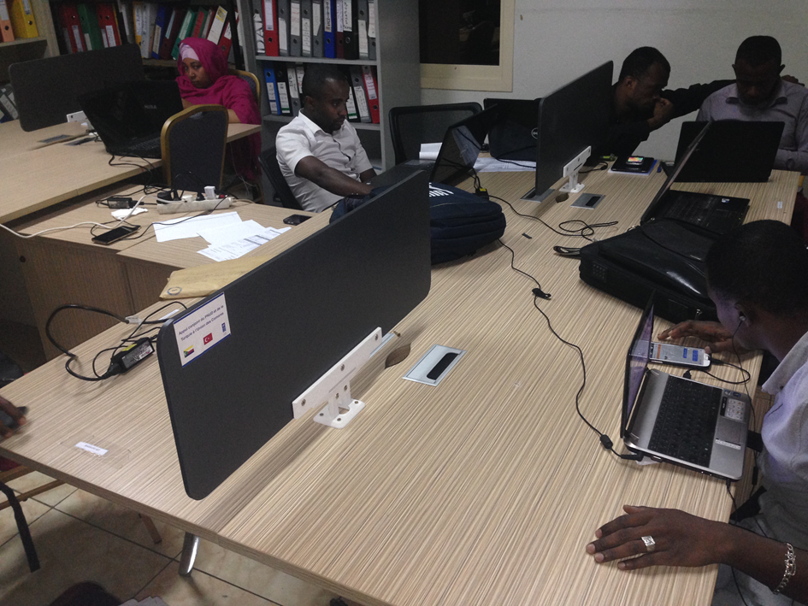

***Salle de travail du Secrétariat Technique Permanent du dispositif de suivi évaluation de la stratégie nationale (Commissariat Général au Plan)***



***Outil de communication***